Content:

* Slide 1 - Career Name & Your Name
* Slide 2 - What your chosen career does
  + 2 points of data minimum
* Slide 3 - How to become a…education required
  + 2 points of data minimum
* Slide 4 - Work Environment
  + 2 points of data minimum
* Slide 5 - Pay (explain - per year and per hour)
  + 2 points of data minimum
* Slide 6 - Job Outlook, 2023 – 33
  + 2 points of data minimum
* Slide 7 - Similar Occupations (@ least 3)
  + 3 points of data minimum
* Slide 8 – Why did you choose this job? Explain.
  + 2 points of data minimum
* Slide 9 – Resource Slide (OOH)

Basic Layout:

* Slide Background
* Font at least size 20
* 3 images minimum
* Animations added.
* Spelling, grammar & be error free.
* Print 9 slides per page & emailed.
* Shared with your classmates

Total Points

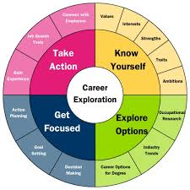

_______ / 2 pts

_______ / 4 pts

_______ / 4 pts

_______ / 4 pts

_______ / 4 pts

_______ / 4 pts

_______ / 6 pts

_______ / 4 pts

_______ / 2 pts

_______ / 2 pts

_______ / 2 pts

_______ / 3 pts

_______ / 5 pts

_______ / 5 pts

_______ / 4 pts

_______ / 5 pts

_______ / 60 pts